Exercise Sheet

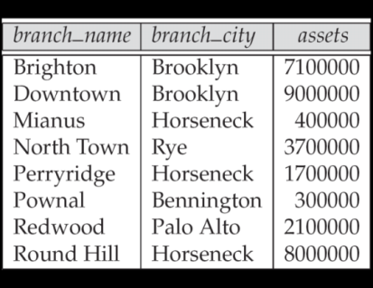
Table Name: Branch

Solve (One has been done for you):
1. Find the name of the branch whose branch_city is Rye.
Answer:
∏_{branch_name}(σ_{branch_city= “Rye”} (Branch))
2. Find assets where branch name is Downtown.
3. Find the name of the branch where asset is less than 3700000.

